FIRE LOG FLAM’UP « BELLES FLAMBÉES » PACKAGE
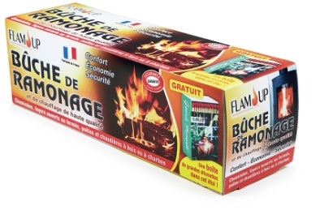
PACKAGE

Characteristics : Belles flambées package, composed of 6 x 1.4 kg logs
1 kg of kindling, 6 wood wool firelighters, 1 box of 100 matches.
Average burn time is approximately 2 hours.
Suitable for fireplaces, inserts and wood-burning stoves.
Certified matches FSC MIXTE N°C106867
Conforms to standard EN 1783:1997
Hazardous. Observe precautions for use
Costoms nomenclature : 44 01 32 00
Size : 360 x 265 x 180 mm
Gross weight : 10.140 kg
Barcode : 3 298 960 923 423

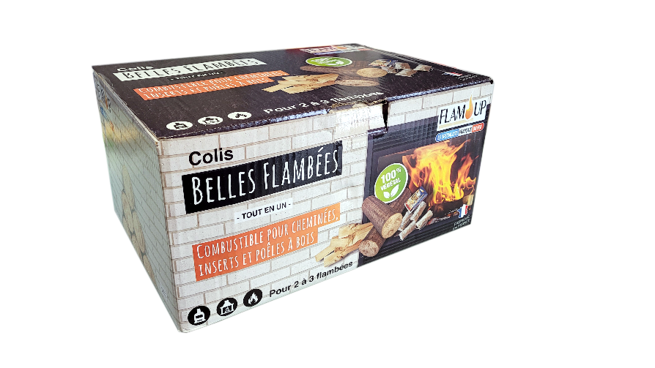

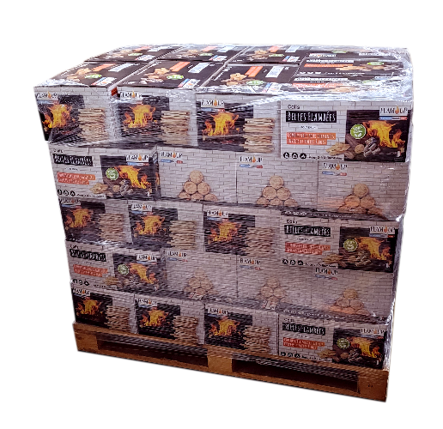
PALETT

Shipping package : 5 layers of 9 cartons, i.e 45 displays per filmed
EUROPE plalett (1 200 x 800 mm).
Stacking : Possible on 2 heights
Size : 1 200 x 800 x 1 050 mm
Net weight: 456 kg - Gross weight : 478 kg
Barcode : 23 298 960 923 434

