FIRELIGHTER FLAM’UP x32 ECOLOGICAL LIGHTER 8 COFFEE GROUNDS PALETS 100% NATURAL
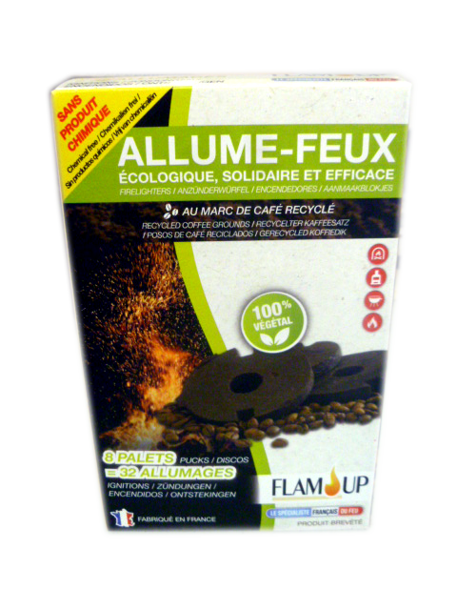
C.S.U – BOX
Characteristics : Coffee grounds-based firelighter,
100% natural, without kerosene or petroleum products.
Paraffin-free
Composition : 30-50% wax and 50-70% coffee grounds.
Box of 8 pallets for 32 ignitions.
For fireplaces, inserts, wood-burning stoves and barbecues.
Powerful firelighter, ecological, supportive and efficient.
Costoms nomenclature : 36 06 90 90
Size : 90 x 142 x 90 mm
Gross weight : 400 gr
Barcode : 3 298 960 923 317

CARTON
Characteristics : Brown cardboard box
Capacity : 10 firelighters boxes
Size : 288 x 205 x 250 mm
Gross weight : 4,2 kg
Barcode : 13 298 960 923 321
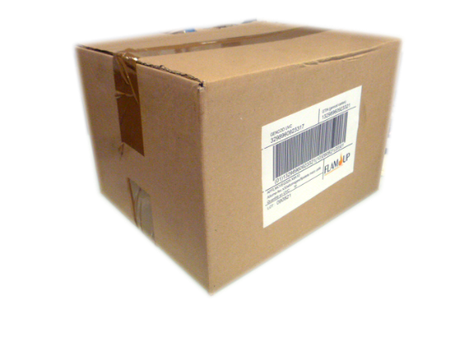

PALETT

Shipping package : 5 layers of 12 cartons, i.e 60 displays per filmed EUROPE plalett (1 200 x 800 mm),
i.e 600 boxes of firelighters.
Stacking : Possible on 2 heights
Size : 1 200 x 800 x 1 175 mm
Net weight : 252 kg - Gross weight : 274 kg
Barcode : 23 298 960 923 335

